- The latest set of changes to the Labour Force Survey still leaves us well short of having usable data for headline UK labour market series. The revisions reduce the discrepancy in levels terms with other sources, but the problem of extreme volatility remains. Frustratingly, the Office for National Statistics has said it could be 2027 before the long-term solution is finally in place.
- Results from the Bank of England's Decision Maker Panel backed our view that the increase in national insurance contributions will raise prices and cut margins, employment, and pay growth. Governor Andrew Bailey has said this is the key source of domestic uncertainty and hinted it means the cut-hold tempo to rate cuts is likely to continue until at least the spring.
The problems with the Office for National Statistics' flagship Labour Force Survey, which supplies the UK's headline employment and unemployment series, have been a long-running saga. Sample sizes have been drifting down for many years, but the fall accelerated during the pandemic. The situation reached its nadir last October when data quality deteriorated to such an extent that the ONS was forced to suspend publication of the data for five months.
The data was reinstated earlier this year, after the series were reweighted using more up-to-date population estimates. This week, the ONS gave notice that the next labour market release on December 17 will see the data reweighted again, this time using the 2022 mid-year population estimates as a starting point and then projecting forwards using scaling factors from the 2021-based population projections.
The new data will raise the level of employment by around 400,000 for Q2 2024, reducing the large gap to other estimates of employment, most notably HMRC's count of employees on payrolls (Chart 1). But this is still likely to be a significant under-estimate of the true employment level, given the population data does not factor in the much higher migration estimates published last week. While a higher population raises all series in level terms, the revised composition makes little difference to rates. Given that the problem of low response rates remains unresolved, the new series will also continue to show extreme volatility.
Chart 1: The next set of LFS revisions will still leave us well short of a proper resolution to the problems
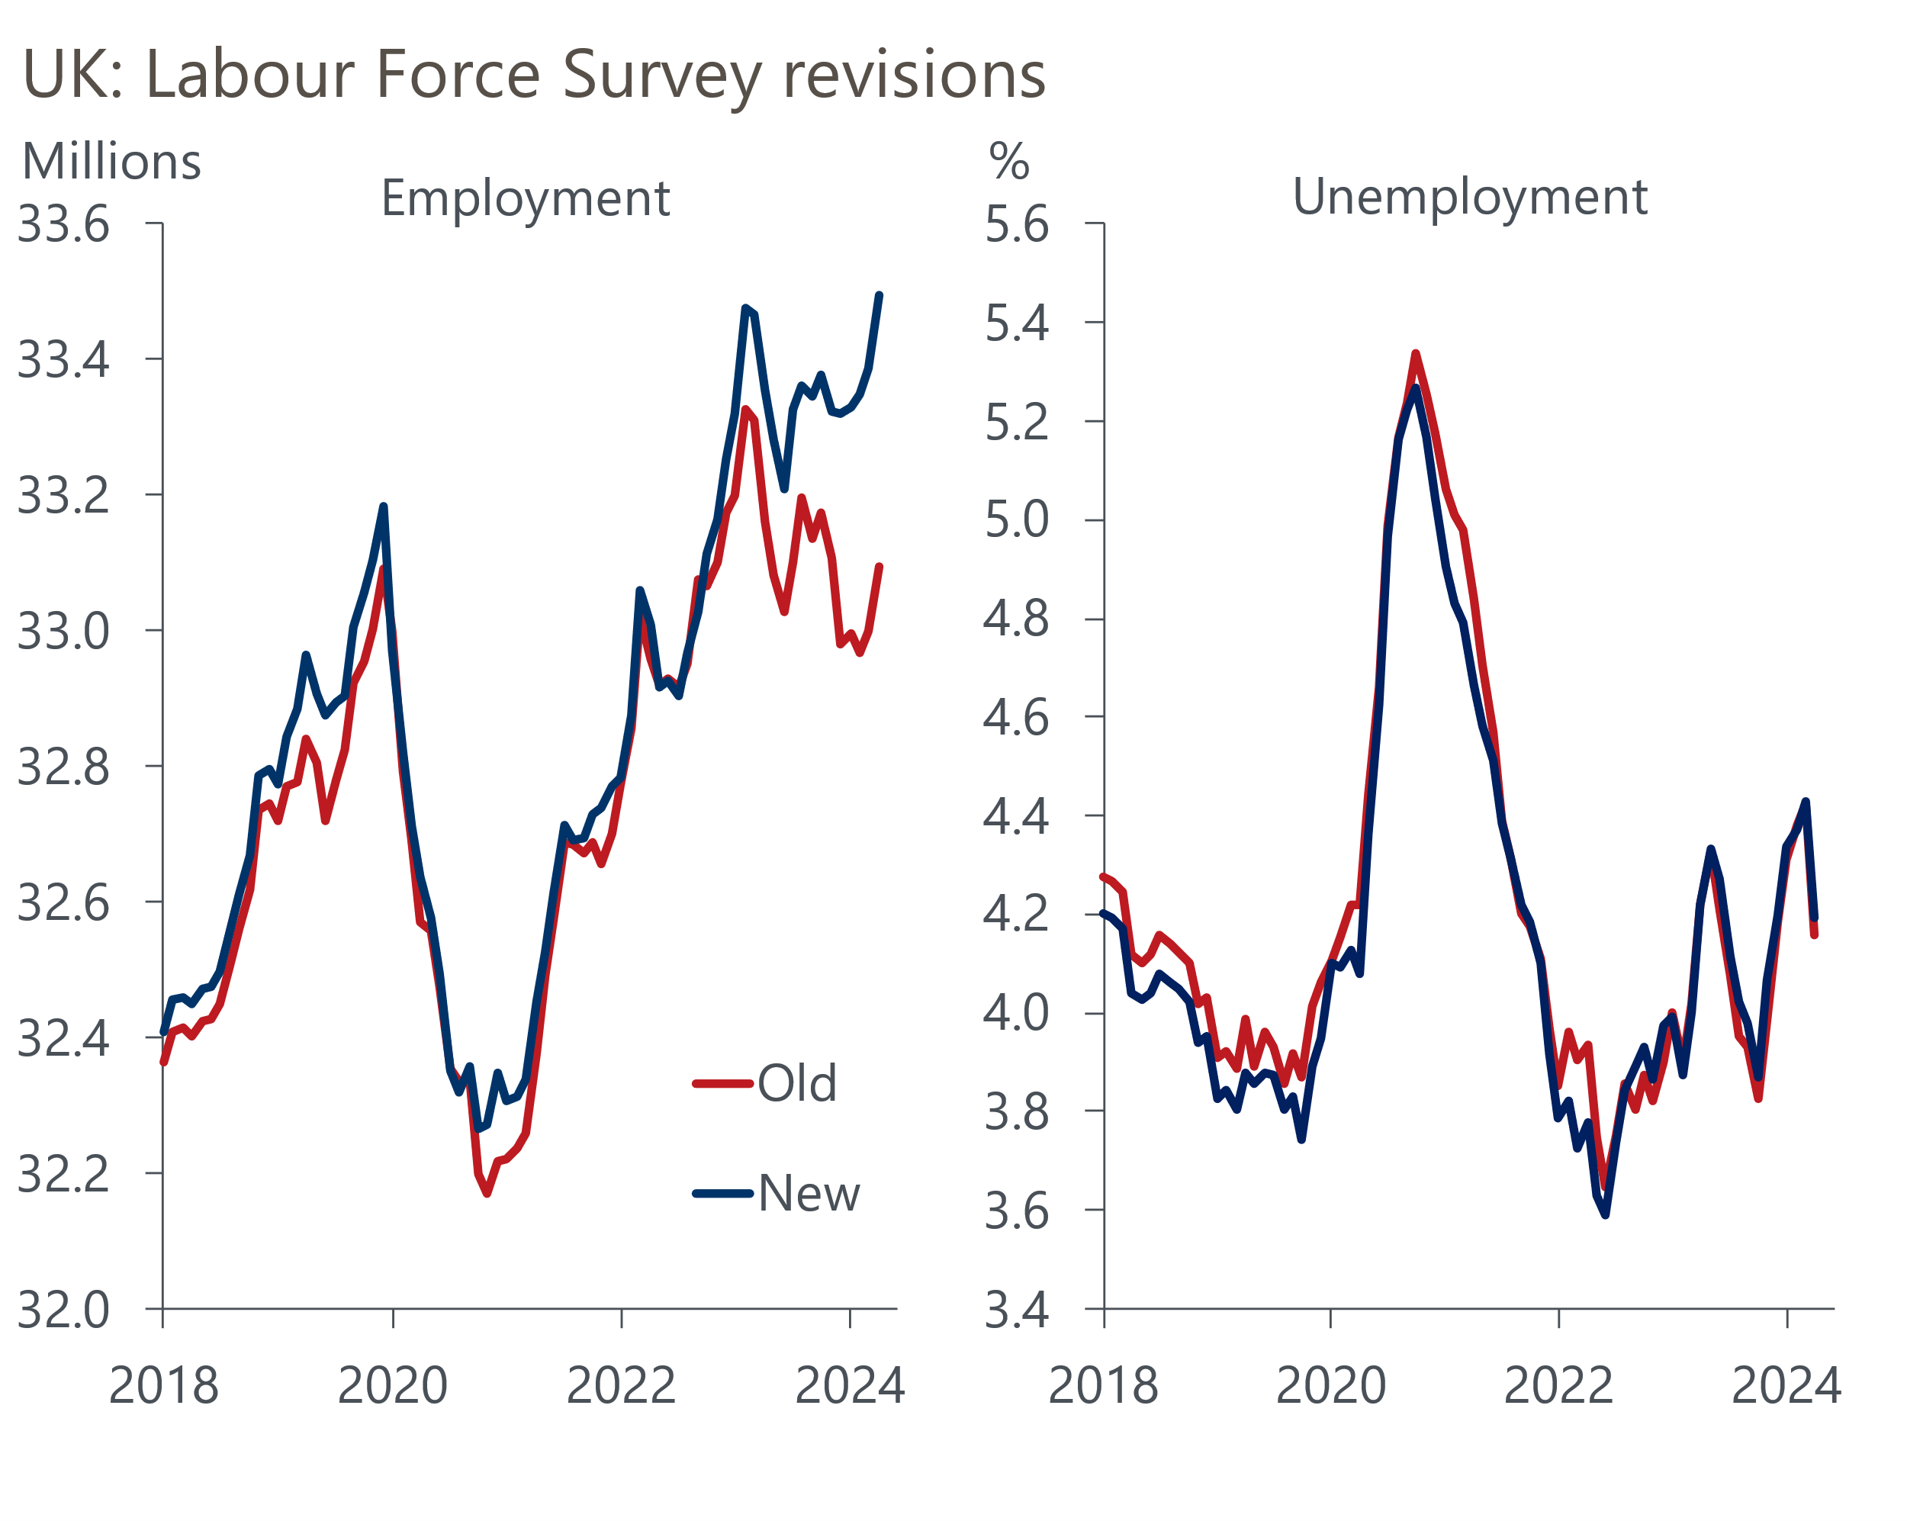
Source: ONS

Regrettably, the solution to the small sample problem seems no closer. When the LFS was suspended last year, the ONS expected the new Transformed LFS – its long-term successor – would be "the primary source for the labour market release in March 2024." But that timetable has progressively slipped. Now the ONS says that transitioning to TLFS in mid-2025 is "unlikely" and its aim is to complete the process in 2027, although there will be further piecemeal improvements to the LFS in the interim.
In our view, the LFS data in its current form is close to worthless. Indeed, the ONS probably made a mistake in reinstating the data earlier this year without having fixed the main problems, because it created a false impression of reliability. Equally, it's hard to see why it will take so long to resolve the problems – if the proposed timetable holds, the UK will endure a four-year period without reliable data for its key labour market series.
Policymakers have been clear about how unsatisfactory this situation is, and Bank of England Governor Andrew Bailey again expressed his frustration this week when he was interviewed as part of the Financial Times' Global Boardroom conference.
The Governor framed his remarks on the monetary policy outlook around the BoE's three inflation scenarios and like most of his colleagues, he gave the impression that he felt the mid-range scenario was most likely to play out. Bailey said that heightened uncertainty – both at home and abroad – around key parts of inflation dynamics was a problem in the near-term. Domestically, he cited the reaction of companies to April's rise in national insurance contributions as the key source of uncertainty, with the concurrent large increase in the national living wage adding to the challenges.
The first evidence of how firms might react to the NICs rise came in the results of the BoE's Decision Maker Panel for November. Just over half of firms expect to lower margins, raise prices, and reduce headcount. The proportion expecting to offer smaller pay rises was lower, but at 38% was still fairly high. In the regular DMP, the NICs rise was likely to be the key reason why the downward trend in firms' price and wage expectations has levelled off of late (Chart 2).
Chart 2: Expectations for future price and wage growth have levelled off in recent months
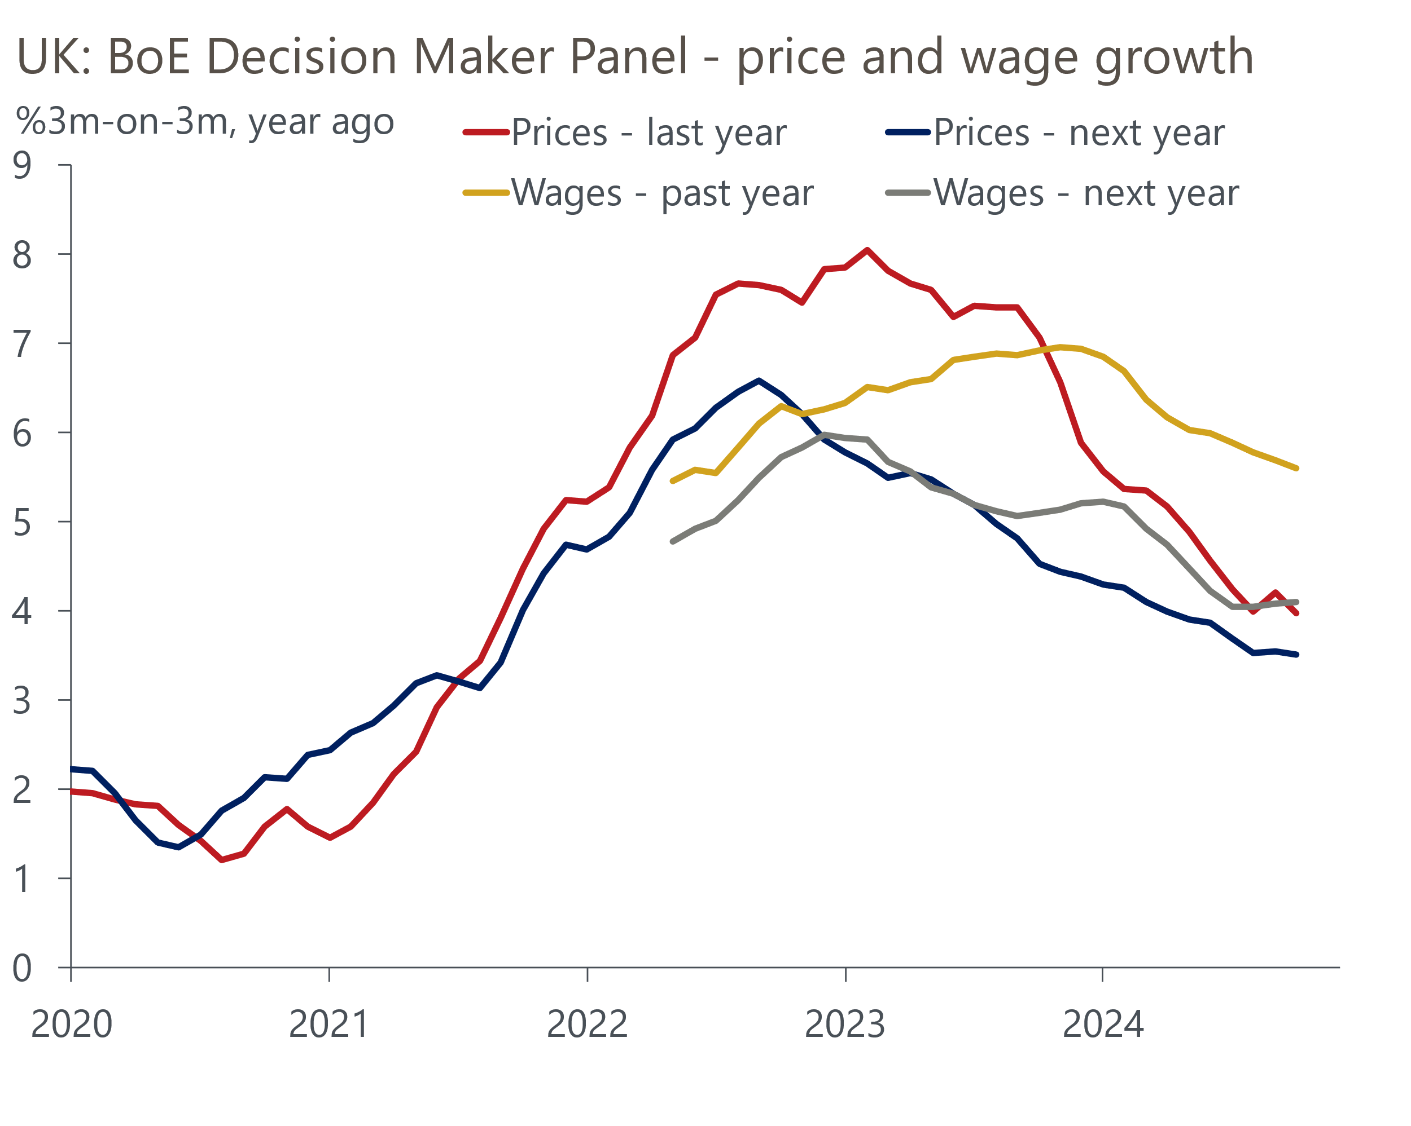
Source: Bank of England Decision Maker Panel
In his interview, Bailey made a point of saying that he thought the Monetary Policy Committee would have a better idea of how the NICs rise was playing out in the spring. This suggests there's a strong chance that the cut-hold tempo to rate cuts continues until at least then. A more abrupt slowdown in activity could force the MPC's hand before then, but we think that's unlikely. Though GDP growth weakened in Q3, this was the third successive year in which that's happened, hinting at a residual seasonality problem. Similarly, though the composite PMI was only just above 50 in November, it's hard to separate genuine trends in activity from the damage to business sentiment from the NICs rise. We think growth will continue at a pace close to trend and that the MPC will continue to cut by 25bps each quarter.

The week ahead
Next week's only major release is the GDP data for October. Recent releases have underwhelmed, with GDP falling by 0.1% month-on-month in September. We've now seen GDP growth slow in Q3 in each of the past three years, suggesting there might be a problem with residual seasonality in the data. But these problems seem to affect Q2/Q3 rather than Q4, so we think there will be a recovery in growth over the latter part of the year.
Several of the sectors that have typically been strong performers in recent years – most notably information and communications and parts of business services – have reported surprisingly soft outturns of late, so we see a good chance that they rebound in October. But that month's poor retail sales outturn suggests distribution output probably fell. Overall, we estimate the GDP grew by 0.2% m/m in October.
Table 1: Week ahead calendar
Date | Events | Period | Measure | Unit | Previous | Forecast
Dec 13 | GfK consumer confidence | Dec | Headline | % bal | -18 | -18
Dec 13 | GDP | Oct | m/m | % | -0.1 | 0.2
Dec 13 | GDP | Oct | 3m/3m | % | 0.2 | 0.1
Dec 13 | Index of services | Oct | m/m | % | 0.0 | 0.2
Dec 13 | Index of services | Oct | 3m/3m | % | 0.1 | 0.2
Dec 13 | Manufacturing output | Oct | m/m | % | -1.0 | 0.3
Dec 13 | Manufacturing output | Oct | y/y | % | -0.7 | 1.0
Dec 13 | Industrial production | Oct | m/m | % | -0.5 | 0.5
Dec 13 | Industrial production | Oct | y/y | % | -1.8 | 0.4
Dec 13 | Construction output | Oct | m/m | % | 0.1 | 0.1
Dec 13 | Construction output | Oct | y/y | % | -0.4 | -0.2
Dec 13 | UK trade | Oct | Trade balance | £bn | -3.5 | -3.0
Dec 13 | UK trade | Oct | Visible balance | £bn | -16.3 | -16.0
Source: Oxford Economics

Key forecasts
Table 2: UK forecast overview
(Annual percentage changes unless specified)
 | 2022 | 2023 | 2024 | 2025 | 2026 | 2027
GDP | 4.8 | 0.3 | 0.9 | 1.4 | 1.7 | 1.8
Private consumption | 7.3 | 0.5 | 0.8 | 1.7 | 1.5 | 1.6
Fixed investment | 5.1 | -0.1 | 1.0 | 0.8 | 3.4 | 2.5
Government consumption | 0.6 | 0.6 | 2.4 | 2.9 | 1.6 | 1.6
Exports of goods and services | 12.6 | -2.2 | -1.9 | 1.9 | 1.6 | 1.5
Imports of goods and services | 13.0 | -3.4 | 2.5 | 2.2 | 1.8 | 1.5
Industrial Production | -6.4 | -1.2 | -1.1 | 0.6 | 1.2 | 1.1
Consumer prices | 9.1 | 7.3 | 2.6 | 3.0 | 2.4 | 2.1
Unemployment rate (%) | 3.9 | 4.0 | 4.3 | 4.4 | 4.3 | 4.2
Current a/c balance (% of GDP) | -2.2 | -2.0 | -3.1 | -2.8 | -2.8 | -2.7
Government balance (% of GDP) | 4.1 | 5.0 | 4.5 | 3.7 | 2.9 | 2.2
Central bank policy rate (%, EOP) | 3.50 | 5.25 | 4.75 | 3.75 | 3.00 | 2.50
10yr govt. bond yield (%, EOP) | 3.67 | 3.54 | 4.30 | 4.16 | 3.79 | 3.41
Exchange rate (US$ per £, EOP) | 1.20 | 1.27 | 1.26 | 1.27 | 1.27 | 1.28
Exchange rate (euro per £, EOP) | 1.13 | 1.15 | 1.20 | 1.20 | 1.20 | 1.20
Source: Oxford Economics
Table 3: Quarterly forecasts for the UK
 | 2024 |  |  |  | 2025
 | Q1 | Q2 | Q3 | Q4 | Q1 | Q2 | Q3 | Q4
GDP (% year) | 0.3 | 0.7 | 1.0 | 1.7 | 1.4 | 1.3 | 1.5 | 1.5
CPI inflation (% year) | 3.5 | 2.1 | 2.1 | 2.6 | 2.8 | 2.9 | 3.3 | 2.9
Bank Rate (%, EOP) | 5.25 | 5.25 | 5.00 | 4.75 | 4.50 | 4.25 | 4.00 | 3.75
10yr gilt yield (%, EOP) | 3.95 | 4.17 | 4.00 | 4.30 | 4.28 | 4.27 | 4.23 | 4.16
US$ per £ (EOP) | 1.26 | 1.26 | 1.34 | 1.26 | 1.26 | 1.26 | 1.27 | 1.27
Euro per £ (EOP) | 1.17 | 1.18 | 1.20 | 1.20 | 1.20 | 1.20 | 1.20 | 1.20
Source: Oxford Economics

Latest Country Economic Forecast:
November 19, 2024

Recent publications

Data Insights
PMI fell in November, but sentiment was likely a driving force
Manufacturing PMI slumped further below 50 in November
Mortgage approvals reached a 26-month high in October
November's PMI won't set alarm bells ringing yet
Retail sales fell in October, but underlying picture remains decent

Research Briefings
Key themes 2025 – Worrying debt dynamics shift into focus
Why the energy shock persisted for firms, but may soon fade
Macro impact of Trump’s tariffs shouldn’t be overstated
MPC sticks to the cut-hold tempo
Markets have soured on the Budget, but calm should return

Contacts

Oxford Economics' UK team
- Andrew Goodwin - Chief UK Economist - agoodwin@oxfordeconomics.com
- Edward Allenby - UK Economist - eallenby@oxfordeconomics.com

